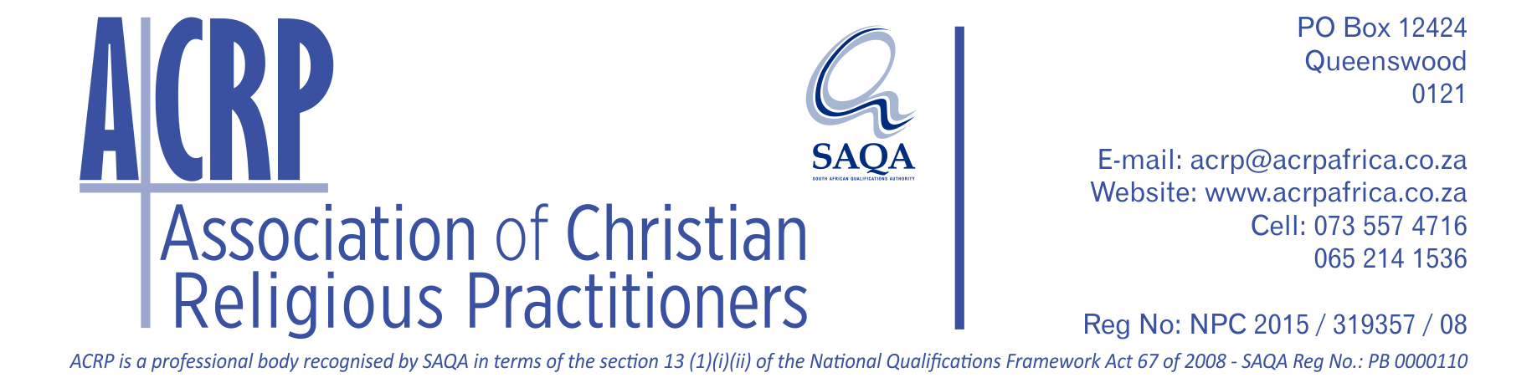

**BRIEF HISTORY OF ACRP**

ACRP was established in 2014 by a representative group of ministry practitioners, representing churches and church networks, other ministry institutions, faculties of theology, seminaries and other training institutions, and chaplaincies. The initiative to bring the parties together went out from the Centre for Contextual Ministry at the University of Pretoria and Bible Media in Wellington, South Africa.

The establishment of the organisation was mainly in response to challenges related to ministry standards and ministry training, as experienced by many Christian churches and ministries in South and sub-Saharan Africa. The needs experienced by churches and ministries in the “independent” or “informal” church environment received special attention. The reality was that a very low percentage, even less than 10% of Christian ministry leaders in South and sub-Saharan Africa, had access to formal ministry training. There are currently more than an estimated 200,000 pastors in South Africa, and more than a million in sub-Saharan Africa, who did not have access in the pat to formal training for the work they do. Other challenges included that, although many informal (non-accredited) training institutions and programmes existed, the work of these training centres were not strategically aligned, were not comprehensive in nature and in some cases, not of an appropriate standard.

The ***South African Qualifications Authority (SAQA)*** indicated that a professional body established in terms of the ***National Qualification Framework Act*** (67 of 2008) would receive the necessary support from statutory institutions to solve the training related problems. This led to the decision to embark on the process to establish the body and to pursue the solution of the challenges as indicated.

In 2016 the SA Association of Pastoral Workers (SAAP) was amalgamated into the organisation and became the Council for Pastoral and Spiritual Counsellors (CPSC) within ACRP. SAAP was founded in 1991 to attend to the professionalisation of, and quality assurance in, pastoral counselling in Southern Africa. CPSC developed a registration and accreditation system which includes the setting of counselling standards and the application of a code of ethics and a disciplinary code for counselling practitioners. The counselling practitioners it represents range from lay pastoral workers and counsellors, to pastors, chaplains and specialist counsellors. Specialist counsellors include private practitioners, family and marriage counsellors, trauma counsellors and mediators. Areas of work include congregations, hospitals, counselling centres and help lines, and uniformed services (the military, police service and correctional services). ACRP will in future also be a vehicle for the functions formerly performed by CPSC. More information on CPSC as a council within ACRP is available from the separate CPSC website **–** visit https://www.cpsc.org.za.

Another addition to the ACRP also occurred during 2016 when the then Association of Christian Counselling (ACC) requested to be merged with SAAP/CPSC and through this, to become part of ACRP. ACC comprised of professional, pastoral and lay counsellors. They represented diversity in practice and training, but shared a commitment to Biblical truth and psychological excellence. ACC’s goals and ethos were well aligned with that of ACRP/CPSC and the inclusion of ACC into the ACRP strengthened the process of professionalisation.

Since its establishment in 2014, ACRP’s management led the process to prepare the application to be recognised by SAQA as professional body. The application was submitted in October 2016 and in 2017 ACRP was formally recognised and registered by SAQA, as professional body for religious professionals, in terms of the NQF Act 67 of 2008.

Currently there are three Councils within ACRP, namely the Council for General Ministry Practitioners (CGMP), the Council for Pastoral and Spiritual Counsellors (CPSC, the former SAAP) and the Council for Ministry Training Practitioners (CMTP).